Health and Social Care - background to what will be covered in : Component 1 Human Lifespan Development
Learning Aim A: Understand human growth and development across life stages and the factors that affect it
How do people grow and develop throughout their lives? How can factors such as lifestyle choices, relationships affect this? Understanding these processes is essential knowledge and understanding for health and social care practitioners.
Growth and development across life stages |  | Factors affecting growth and development
Lifestages  - Infancy (0 – 2 years)  - Early childhood (3 – 8 years)  - Adolescence (9 – 18 years)  - Early adulthood (19 – 45 years)  - Middle adulthood (46 – 65 years)  - Later adulthood (65+ years)  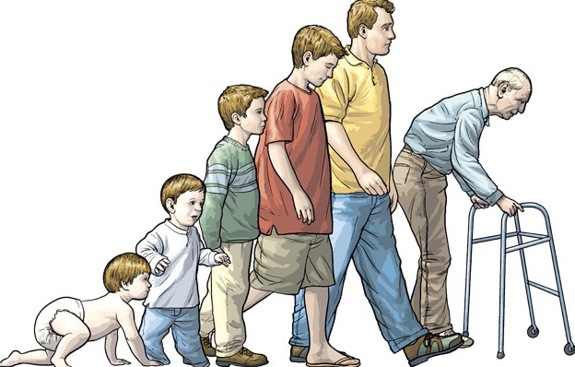 | Holistic Development  - Physical development – Physical growth and physiological change  - Intellectual development – Developing thinking and language skill and common activities that promote learning and development  - Emotional development – Developing feelings about self and other  - Social development – Forming relationships | 1. Physical factors  - Genetic inheritance  - Diet and lifestyle choices  - Experience of illness and disease  - Appearance | 2. Economic factors  - Income/ wealth  - Material possessions
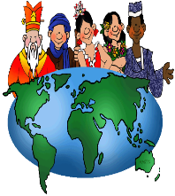
3. Social, Cultural and emotional factors
- Educational experiences
- Culture, e.g. community involvement, religion, gender
- Influence of role models
- Influence of social isolation
- Personal relationship with friends and family
Learning Aim B: Investigate how individuals deal with life events
Different types of life event |  | Coping with change caused by life events
1. Physical events  - Accident/ injury  - Ill health | 3. Life circumstances  - Moving house, school or job  - Exclusion from education  - Redundancy  - Imprisonment    - Retirement | - How individuals adapt to these changes  - Sources of support  - Family, friends partners  - Professional carers and services  - Community groups, voluntary and faith based organisations
2. Relationship changes
- Entering a relationship

- Marriage
- Divorce
- Parenthood
- Bereavement

- Types of support
- Emotional
- Information advice
- Practical help, e.g. financial assistance, childcare, transport

