Health and Social Care – background information for : Component 3 Health and Wellbeing
LAA Factors that affect health and wellbeing | LAB Interpreting health indicators | LAC Person centred health and wellbeing improvement plans
A1 Factors affecting health and wellbeing  - Definition of health and wellbeing  - A combination of physical health and social and emotional wellbeing, and not just the absence of disease or illness  - Physical and lifestyle factors that can have positive or negative effects on health and wellbeing:  - Genetic inheritance, including inherited conditions and predisposition to other conditions  - Ill health (acute and chronic)  - Diet (balance, quality and amount)  - Amount of exercise  - Substance user, including alcohol, nicotine, illegal drugs and misuse of prescribed drugs  - Personal hygiene  - Social, emotional and cultural factors that can have positive or negative effects on health and wellbeing:  - Social interactions, e.g. supportive/ unsupportive relationships, social intergration/ isolation  - Stress, e.g. work-related  - Willingness to seek help or access services, e.g. influenced by culture, gender, education  - Economic factors that have a positive or negative effect on health and well-being  - Financial resources  - Environmental factors that can have a positive or negative effect on health and well-being:  - Environmental conditions, e.g. levels of pollution, noise  - Housing, e.g. conditions, location  - The impact of life events relating to relationship changes and changes in life circumstances | B1 Physiological indicators  - Physiological indicators that are used to measure health:  - Pulse (resting and recovery rate after exercise)  - Blood  - Peak flow  - Body mass index (BMI)  - Using published guidance to interpret data relating to these physiological indicators  - The potential significance of abnormal readings: risks to physical health | C1 Health and wellbeing improvement plans  - The importance of a person-centred approach that takes into account an individual’s needs, wishes and circumstances  - Information to be included in plan:  - Recommended actions to improve health and wellbeing  - Short term (less than 6 months) and long term targets  - Appropriate sources of support (Formal and/ or informal)
 | B2 Lifestyle indicators  - Interpretation of lifestyle data, specifically risks to physical health associated with:  - Smoking  - Alcohol consumption  - Inactive lifestyles  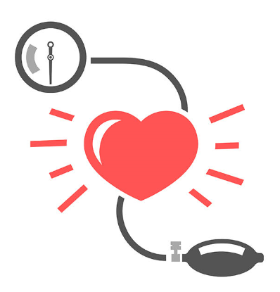  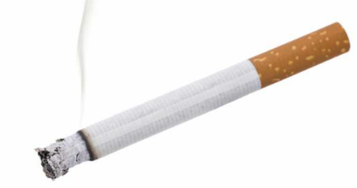 | C2 Obstacles to implementing plans  - Potential obstacles  - Emotional/ psychological – lack of motivation, low self-esteem, acceptance of current state  - Time constraints – work and family commitments  - Availability of resources – financial, physical, e.g. equipment  - Unachievable targets – unachievable for the individual or unrealistic timescale  - Lack of support, e.g.from family and friends  - Other factors specific to individual – ability/ disability, addiction  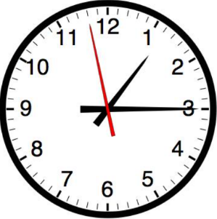  - Barriers to accessing identified serv ices

